
Version 7.2
Updates history

Version 7.2.82 | 27/06/2010

Printings for 1:1 scale bows : WinPro allows to print the bow part of a window with a 1:1 from the Drawing tab of the order (to be used with appropriate print tables).

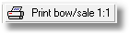
New keys into WinPro.ini are created to control the pen thickness onto the printings.

[Bow Drawing]
Frame big pen width = Thickness of the big pen for the outer frame (default 0.5).
Frame small pen width = Thickness of the small pen for the outer frame (default 0.2).
Sash big pen width = Thickness of the big pen for the sash frame (default 0.5).
Sash small pen width = Thickness of the small pen for the sash frame (default 0.2).

Version 7.2.80 | 27/06/2010

Fix for variable _OuterFrameShape in case of a false arch type 2 or 3, this variable will always be worth _Rectangle.

Version 7.2.79 | 27/06/2010

Variables added related to false arches: Add of a new global variable _FalseAerchHeight returning the height of the false arch as it has been input.
It returns zero as default value when a false arch is input with the « Arrow » greyed.
Add of a second variable _FalseArchExtraHeight returning the value input into the « Extra height » field of the false arch input dialog.

Version 7.2.78 | 27/06/2010

Modification of the « Commercial user » access right: User access right labelled Customer (customer file maintenance), Prospect (prospect file maintenance) and Accounting (accounting data handling) are now definable for users that are granted only with the limited « Commercial user » access right.

Version 7.2.77 | 27/06/2010
Tables modifiées |  | Tables créées | Index modifiés
Article.dbf |  | ??? | ???

Supplier order creation dialog: Into this dialog, accessed through menu Stock | Create supplier order, WinPro shows now the supplier description of articles rather than the base article description.

Deleted field: The « LAQUE » field from table Article a is deleted as out of date.

Version 7.2.74 | 27/06/2010

Articles deletion: The deletion of an article is disallowed now when article is part of an existing composed article.

Version 7.2.73 | 27/06/2010

Printing of glass dimensions onto quotations for WinPro/D: The key « Glass Dim On Quotation » of the [Documents] section of WinPro.ini file allows now to print or not the glazing dimensions onto quotations, for WinPro/D only.
[Documents]
Glass Dim On Quotation = 0 no glass dimensions onto quotations from WinPro/D (default).
= 1 glazing dimensions are printed onto WinPro/D’s quotations.

Version 7.2.72 | 27/06/2010

Batch packing dialog at optimization: The « Pack » key from section [System] of WinPro.ini file allows to enable or not the dialog inviting the user to pack the batch FoxPro files, at the end of optimization.
[System]
Pack = 0 no pack dialog for batches, no pack processed.
= 1 pack dialog displayed for batch files at the end of optimization (default value).

Extended door sill for door design: The key « Seuil etendu = 1 » from [System] section of WinPro.ini allows to enable the extended door sill feature, for doors only. This feature sets the continuiity of a door sill regarding the outerframe sides or mullions.
Once the key is enabled, a new combo will be available at the door sill input level:

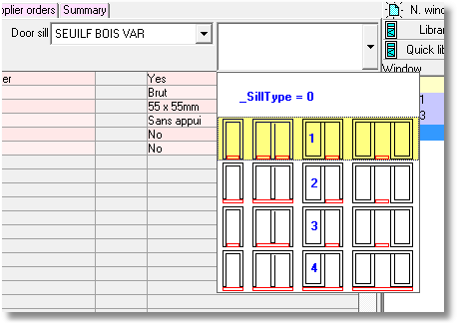

This dialog will set a variable, _SillType, available at all level of frame across the WinPro set up. This variable will contain :
* -1 when no sill installation is se and when the sill is checked « Door sill (under frame) ».
* -2 when no sill installation is se and when the sill is checked « Door sill (inside frame) »
* 0 when no sill installation is se and when the sill is not checked « Door sill (inside/under frame) », or when no door sill is input for the design
* 1 when the first installation is applied
* 2 when the second installation is applied
* 3 when the third installation is applied
* 4 when the fourth installation is applied
When the key « Seuil etendu = 0 », the _SillType variable will return the following values:
* 0 in case of no door sill set, or if the sill is inchecked for both « Door sill (under/inside frame) »
* -1 for a door sill checked as «Door sill (under frame) »
* -1 for a door sill checked as «Door sill (inside frame) »

Version 7.2.71 | 09/04/2008
Modified tables |  | Created tables | Modified index
??? |  | ??? | ???

Clearance for panels : The clearance is now deduced from articles consumed into the Description page of the panel set up dialog, when those articles contains a macro #2# to be replaced.
Previously, WinPro deduced the clearance of the panel for a macro located into its Description tab, but not for the article consumed in the same page

Reservations recomputation: WinPro now fullfills table ParArt à each time reservations are recomputed from the corresponding tab of the order, which was previously not done.

Weights onto customer documents: It is now possible to print weights values for every single design, as well as total weight calculated for an order or quote. This feature is enabled when both below described keys are set into winpro.ini file (or settings table using version 8)
[Customer order]
Weight = 0 current behaviour of the program (default value)
= 1 print weight values for each design

Order = 0 current behaviour of the program (default value)
= 1 print total weight value for the order

Version 7.2.70 | 27/06/2010

Import/Export quotation and customers for WinPro/D: It is now pssible to export quotations input into WinPro/D as well as created customers, using menus Tools | Customer(s) and quotation export/import.
Quotations and customers records are respectively exported to files with formats « *.WPX » and « *.WPT », into the base directory of WinPro/D.
Quotations and/or customers must be located into the base directory of WinPro/D to be imported.

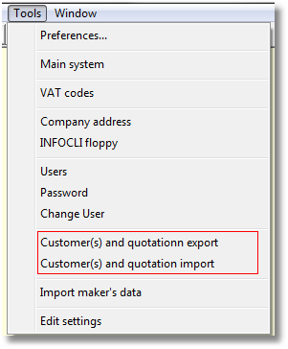

Version 7.2.64 | 22/01/2008
Modified tables |  | Created tables | Modified index
??? |  | ??? | ???

Archiving orders and quotations: Until now, WinPro only allowed archiving for invoiced orders.
You have now the ability to archive orders and quotation regardless of their respective statuses. This archiving feature is available via the menu point: Orders | Delivery handling | Archive orders and quotations.

Version 7.2.58 | 28/09/2007
Modified tables |  | Created tables | Modified index
??? |  | ??? | ???

Specific VAT for installation: You may need, depending on the area of the world you are from, to use a specific VAT/tax rate for the installation price.
A new key is then available into Winpro.ini file or settings table (for version 8), which enables a new input field for this value at order input level.

[VAT]
TvaPose = 1 to enable the feature
= 0 to disable the feature (default value)

Colour for composed panels: Add of a key into Winpro.ini file or settings table (version8), controlling colour management for composed panels:
[System]
PanneauFabriqueDormant = 0 Standard WinPro’s behaviour (default value),
panel with sash colour in case no colour is set for the composed panel by the user.
= 1 In case no colour is set for the panel AND the panel is part of a fixed pane, panel will be consumed into outer frame colour.

Ventilators: Add of a new into Winpro.ini file or settings table (version8), controlling colour management regarding ventilators:
[System]
AerateurDormant = 0 Standard WinPro’s behaviour (default value),
Ventilator with sash colour in case no colour is set by the user.
= 1 In case no colour is set for the ventilator AND the ventilator is part of a fixed pane, ventilator will be consumed into outer frame colour.

Croisillons avec aérateur : Add of a new into Winpro.ini file or settings table (version8), controlling position management of glazing bars used along with ventilators:
[System]
CroisillonAvecAerateur = 1 Standard WinPro’s behaviour (default value),
Axis calculated considering ventilator(s) thickness(es) if there is(are).
= 0 Winpro calculates bars axis regardless of the ventilator thickness.

Version 7.2.56 | 28/09/2007
Modified tables |  | Created tables | Modified index
??? |  | ??? | ???

Optimization list: In order to decrease your paper consumption when printing optimization lists, you may hide the drawing of the cutting sequences onto the document, using a new WinPro.ini key (or settings table key for version 8).
[Optimisation]
Draw On Optimization List = 0 Document showing cutting sequence drawing
=1 Document hiding cutting sequence drawing
(default value)

Version 7.2.53 | 10/07/2007
Modified tables |  | Created tables | Modified index
??? |  | ??? | ???

Text displayed onto roller shutter box drawing: A new field is available at roller shutter box set up level, Description tab, labelled « Text on drawing ». The field’s content will be displayed on screen, and printed onto customer documents, on the foreground of the box drawing.
Print bow/sale 1:1 : You may now print separately the outer frame and sash frame when bowed. Winpro would now print 2 documents instead of stacing outer frame and sash frame onto the same layer.
This feature is enabled adding a key into WinPro.ini file:
[System]
Print bow 1:1 by frames = 0 Same document for both frames (default value)
= 1 One document by frame

Version 7.2.50 | 08/06/2007
Modified tables |  | Created tables | Modified index
??? |  | ??? | ???

Orders and quotations labelling : Winpro may now create order and quotation codes using the customer code as prefix. This is done with adding the following key into WinPro.ini file:

[Prefixes]
PrefixeClient = 0 No customer code as prefix (default value)
= 1 Coustomer code as prefix for orders & quotations
- Before clicking New Quote or New Order buttons, you should have set the customer code into the dialog, as shown below.
In case one of both conditions is not fullfilled, WinPro will create a code based onto the prefix defined into the Preferences dialog of the Tools menu.
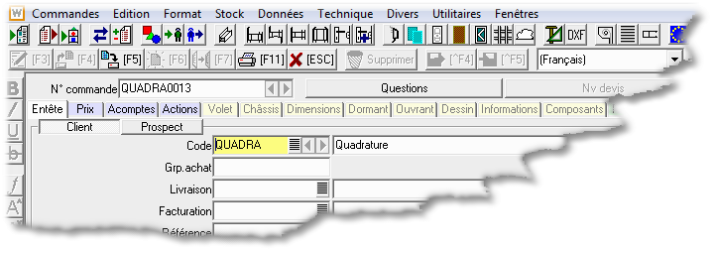

Version 7.2.49 | 29/05/2007
Modified tables |  | Created tables | Modified index
??? |  | ??? | ???

Export tables: When deleting a customer order, information sent into export tables for this order may now be cleaned as well as generated drawings, considering the value of the following WinPro.ini new key.
[System]
VideTablesExport = 0 Winpro never deletes exported datas = 1 Winpro systematically deletes exported datas.
= 2 Winpro deletes exported datas on demand.

Version 7.2.46 | 04/05/2007
Modified tables |  | Created tables | Modified index
DetTarif.dbf |  | ??? | ???

List price creation: When inputing a list price using WinPro, users may now:
- Input a door sill beneath the outer frame as it can be done during order input stage, through a combo list.
- Select a door sill configuration as during order input, and if the WinPro.ini key related to extended door sil lis enables
- Input a Ral colour for the sill => Inside and outside colour of the design.
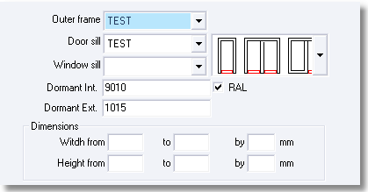

Version 7.2.45 | 27/04/2007
Modified tables |  | Created tables | Modified index
??? |  | ??? | ???

Glazing bars: Simplified input of colours:
- Input fields for « Inner coulour » and « Outter colour » coulour of glazing bars reversed, the outter colour is shown first now.
- The scroll list of « Outter colour » displays all allowed colours OR all colours not forbidden.
- The « Inner colour » field is now greyed when it is forbidden to use a bicoloration for this glazing bar, and is automatically completed with the code of the « Inner collour » by Winpro.
- The « Inner colour » scroll list now displays:
  - All allowed mono colours OR all mono colours not forbidden, in case of no bicolouration at the outter side.
  - Only the inner colour defined into the bicolouration input as the « Outter colour » (=>outter colour input is bicolour)

Version 7.2.44 | 09/03/2007
Modified tables |  | Created tables | Modified index
Rehausse.dbf  Detail2.dbf  Representant.dbf |  | ??? | ???

Peripheral profile deduced by default: It is now possible to set a default position for such profiles, as well as when the profile should be deduced by default from the design height.
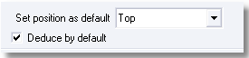

Copy of Order/Quotation : When duplicating a qote, the software will offer possibilities to converti t into order, and then if an automatic numbering based onto prefixes for Orders and Quotations is required

Summary notebook:
A new column is inserted between « Des. » and « Total ». This field shows the value of the installation components dispatched on the locations of an order, and/or assigned to the concerned design.
Into ,the central bottom area of the dialog was the line « Installation », renamed as « Non-dispatched installation ».
Into totals, a new line appear as “Dispatched installation”. This amount correspond to the total of all installations dispatched and/or affected to particular designs.

Localisation of designs: A new text fiel dis available into the « Design » tab of the order, and allows to specify information related to the design in progress. This will be systematically used as a label for the design and will be available through all tabs of the order, as shown below..
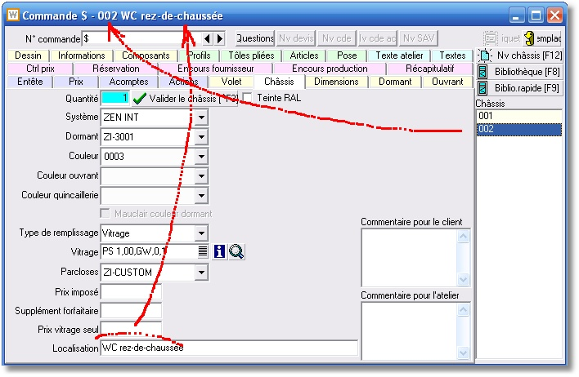

Moreover, this localisation information will be used into the Installation tab.

Installation assignment wizard:
The « Design » field of the Installation tab of an order is not free anymore. It is converted as combo list showing the list of the different designs of the order including their own localizations. This in order to speed up installation input, and to avoid assignment errors of installation-design.
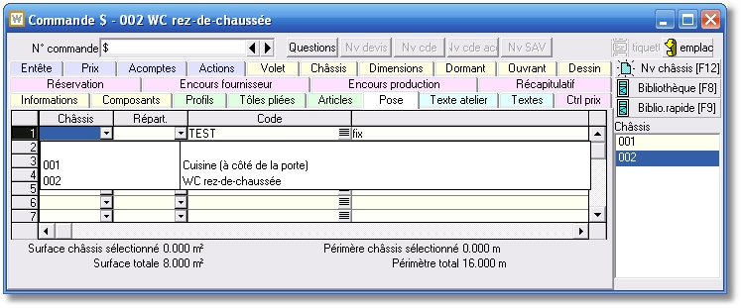

In the lower area are shown Surface and Total Perimeter for the whole designs, as well as Localization, Surface and Perimeter for the design indicated into the « Design » field of the selected line.
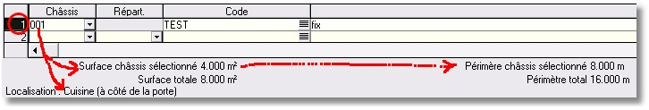

Automatic calculation of installation items: When setting up installation items with rules, you may define the method automatically applied by WinPro to correctly quantify the installation item within an order/quote.
You may then quantify the item for installation as square meters with the Surface check box, or as line meters, as required: for instance 2x height + 1x width.
At order input stage, the « Qty » column will automatically be completed by Winpro as long as a location is selected, and the automatic counting method is defined in the installation item.
The calculated quantity may be modified by user.

Representative : A new « Tel n° » added intoto the representative file.

Version 7.2.43 | 01/03/2007
Modified tables |  | Created tables | Modified index
??? |  | ??? | ???

Cover import module (COV): This module allows to imprt Cover orders into WinPro using XML files generated by Cover.
A new button “Cover Import", located into the « Header » tab of the order/quote, is available for this feature.

A Cover order importation will generate designs for WinPro, under certain circumstances:
- The Cover design code must correspond to a design code stored into an existing WinPro design library.
- The shape of the design must correspond to a shape of a design stored into a winPro library. No tolerance of dimension is allowed.
If those conditions are fullfilled, Winpro add a new design into the order/quote, retrieving dimensions, colours and location name from the Cover file.
Imported design may be modified by WinPro afterward.
The feature does not support multiple Cover order importation within a single WinPro order/quote.
When re-importing a Cover order already imported into WinPro, the designs included in Cover order are not imported again, they are excluded from the import process.
A cover importation process generate also accessories, articles and profiles and display those components into the new "Cover Components " tab of Winpro’s order/quote.
The milling operations linked to the profiles are also imported and listed into the same tab. They may be retrived by the machines if required, with an adaptation of the driver.
The content of this tab cannot be customized.
The end of a profile imported by Cover may accept 2x2 angle values, 2 angles for each end. Additionnal angles compared to winPro process will be converted as milling operation during importation process.
Cover Components are managed into stock like articles and profiles input into Article and Profile tabs of the order/quote.
Cover Components may be printed or not onto commercial documents. The set up is done at article file level, where you will find 2 new checkboxes, respectively " Cover customer doc", “Cover valued".
The list selling price is defined through a new "Cover list selling price". field
When re-importing a Cover order into WinPro, the content of the « Cover Component » tab is completly emptied then reimported.

Accessory profiles from Cover are managed at production level as accessory profiles input into the Profile tab of the Winpro order/quote.
Labour times from Cover are stored into the dedicated « Cover » field located into the Header tab of WinPro order/quote. They are cumulated to labour times already calculated by WinPro, but will never be valued.
A cover.ini file must be initialized when implementing this feature.

Version 7.2.42 | 26/02/2007
Modified tables |  | Created tables | Modified index
??? |  | Finition.dbf | ???

EDIV (Glassver only):
Possibility to add into the filename a macro #2# which will be replaced with the code of the production line
As a reminder, macro #1# is already replaced with the batch code or batch name from WinPro.

Finitions: A level of finition may be enabled using the new checkbox « Finition » at system set up level. Those finitions are to be set into menu Technic | Windows | Finitions.
When « Finition » box is checked, a new checkbox labelled « Limit finition choice ».

A new button "Finition" is added within order/quote input dialog, when the system level box « Finition » is checked, and involves the display of a new finition input dialog. This dialog allows a free input of finitions, or input of a limited combo list according the status of the system checkbox “Limite finition choice”.

Variables FinishingInt and Finishing are initialized by Winpro with the value of the category corresponding to the finition input by the user. Those variables are local to the outer frame, sash, outer frame & sash transom, peripheral profile and beads set up by rule.

Global variables are also available:
_ FrameFinishingIn
_SashFinishingIn [] indexed onto the sash number
_MullionFinishingIn [] indexed onto the sash number
_TransomFinishingIn [] indexed onto the transom number
_GlazingbeadFinishingExt [] indexed onto the filling number
_PerimeterFinishingIn [] indexed onto the peripheral profile number
_FrameFinishingExt
_SashFinishingExt [] indexed onto the sash number
_MullionFinishingExt [] indexed onto the sash number
_TransomFinishingExt [] indexed onto the transom number
_PerimeterFinishingExt [] indexed onto the peripheral profile number

None of those variable can be modified by formulae, and default value is null.

New macros are also available, with a similar use than existing macros: #1#, #2#, …, #6#
Those macros #Fint# and #Fext# used into description fields of components consumed through the set up, will be replaced by the description of corresponding finitions.

Version 7.2.38 | 15/12/2006
Modified tables |  | Created tables | Modified index
??? |  | ??? | ???

Informations tab: Questions related to composed panels are now displayed into this tab of the customer order/quote.

Access to button "Print F11": Using a new key into WinPro.ini file, you may now program this button to be unavailable until the order/quote is edited.
[Systeme]
PasImprimerSiEdition = 1 to enable the feature

WinproD data export: WinproD can also now export datas.

New drawing instruction with continuity level:
This instruction complete the list detailled into release note 7.2.29.
ArcSensRotation(0 ou 1) : defined the rotation direction of defined arches following this instruction.

Curseur of precision for optimization: The default position of this cursor may now be programmed with a new key into WinPro.ini
[Optimisation]
MaxLoop= 0 to 8, for +speed to +precision
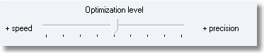

Transoms input: A third value added to the below key. In case of value 2, WinPro will no more remember any position settings for transoms. Voir RN 7.2.28
[System]
Traverse Static = 0(remember settings of the first transom input)
= 1(remember settings of the last transom input)
= 2(settings not remembered)

Technical export: A new menu entry“Technical export” is added at the Utilities menu level. This feature export into a separate directory labelled “technique” the full dbf tables concerned by the technical set up.
You may for instance work on a “developpement” version then, using a technical export, update a “production” database. You may then transfer datas as long as version number of both version are equivalent.
Before proceeding to such a copy from “technique” to “data” directory, be sure that hot datas will not be erased when transfering tables.
It is also possible for you to ask Quadrature to exclude certain table from the technical export, if specifically required by your needs.

Version 7.2.37 | 23/ 11/2006
Modified tables |  | Created tables | Modified index
Commande.dbf  Colis.dbf  ClrCmp.dbf |  | BLfac.dbf  facPose.dbf | ???
Additionnal supplies: Profiles: The input is now possible with up to 1 decimal.
Partial delivery and invoicing (module LFP): An order can be delivered and invoiced partially.
Here are some of the available features with the module:
- The total amount invoiced will correspond now to the confirmed total amount to the customer with relying on down payments, invoiced or not.
- The installation may now be partially invoiced.
- You may invoice partially before partially deliver the order.
- This module needs the package management module to be enabled as we manage with delivery and invoicing for packages.
- The automatic pricing of packages done by WinPro will correspond to amounts confirmed to customers, it is then recommended to work using hidden discount feature when inputing orders or quotes.
- Users may now the default pricing method of each package.
- As soon as an order is approved, it is available for packaging process.
- A box “Packaging complete” is added to the package creation interface, and will allow the user who prepare the packages that the packaging is complete for this order, even though some articles are not yet packaged.
- For a proper delivery with or without partial feature, the orders to deliver must have been fully optmized and the Delivery Preparation note must have been printed.
- The partial delivery note may be priced or not, considering the status of the checkbox “Valorisation” for delivery note, located into the Header tab of the order or quotation.
- Every printed document may be printed again
New statuses added for orders:
802: Partial delivery: The order is fully invoiced and nothing is delivered (Mauve colour)
810: Partial delivery and Invoicing: The order is partially delivered and invoiced (Salmon colour)
852: Partial invoicing: The order is fully delivered and nothing has been invoiced (Gree colour)
860: The order is fully delivered and invoiced using several invoices and delivery notes.
Reminder:
740: Printing of Delivery Preparation Note
850: Order is invoiced and delivered with standard method, no partial delivery/invoice used.

Standard RAL colours enabled by faces: When using the limited choice of standard RAL colour feature with enabling it through the appropriate checkbox into the Colour tab of the System set up dialog, Winpro shows now a new button, « Faces choice», which will enable availability of colour input by faces, Inside and Outside, during order/quote input stage. Both option are disabled by default, this status is interpreted by WinPro as if checked simultaneously.

Version 7.2.36 | 16/ 11/2006
Modified tables |  | Created tables | Modified index
??? |  | ??? | ???

New variable : _OrderSatus : returns one of the following values: 100=Quotation; 200=Order not yet processed; 210=Modified order; 220=Confirmation printed; 240=Confirmation checked; 250=Supplier order printed; 260=Financial approval done; 280=Confirmation sent; 398=Order on hold; 399=Order reactivated after put on hold; 400=Order approval; 420=Glazing order; 499=Preparation for optimization; 500=Optimization complete; 501=Partial optimization; 600=Complete production launch process; 601=Partial production launch process; 700=End of production; 740=Delivery preparation; 800=delivery note; 850=Invoicing; 900=Closed
Note:New statuses may be added to the existing list in the future, as done with version 7.2.37

Version 7.2.35 | 10/ 11/2006
Modified tables |  | Created tables | Modified index
Detail.dbf |  | ??? | ???

New variables : _DateCreatingWindowLot et _DateCreatingShutterLot: Both variables return the date of the batch creation, related to the associated design.
Attention, both 2 variables are initialized when clicking onto the « Generat batches » button of the batch creation interface for the Production Line Management module GLP. They are never initialized if the GLP module is not used.

Fillings category: A second field added to the fillings set up dialogs. Those fields are setting up a new global array variable, _FillingCateg2 [ ], which properties are similar with the _ FilCateg [ ] variable ones.

Version 7.2.34 | 6/ 11/2006
Modified tables |  | Created tables | Modified index
Detail.dbf |  | ??? | ???

Export a DXF cut-through (module DXFC) : When enabled, this module gives now access to a new button into the Drawing tab of the customer order and quotation. This button will export now any defined cut-throughs of this dialog. The exported file is now workable using your usual CAD software.

Version 7.2.33 | 30/ 10/2006
Modified tables |  | Created tables | Modified index
??? |  | ??? | ???
Optimization using a macro into profile description: In order to prepare the bar optimization calculation, Winpro will group the cuts according their respective colours. When profile descriptions contain macros (for instance #3#), Winpro can eventually consider this macro for grouping purpose. Using this feature will force WinPro to group the cut considering colours AND macros.
For WinPro to use this feature, just check a new box into the the Optimization tabs of concerned profiles, named as “Identical Cuts”.
Version 7.2.32 | 24/10/2006
Modified tables |  | Created tables | Modified index
??? |  | ??? | ???

Optimization using a macro into profile description: A new checkbox to group “Identical cuts” is available into the Optimization tab of Profile set up.
This bow is to be checked by user to decide when Winpro have to consider macros into profile descriptions or not.
When checked, at optimization stage, bars will be splitted according colours and descriptions.
When unchecked, at optimization stage, bars will be splitted according colours only.
Orders projects (module CDC): An orders project groups a list of customer orders, and is created by the user (if he has the create order user access right) through menu Orders|Orders Project. The customer orders can then be associated to the new orders project using a new related field, into the Header tab of the customer order.
Attention It will not be possible to associate a customer order for customer X to an order project for customer Y.
It is anyway possible to open simultaneously several customer orders from a given project while this project is visualized into the appropriate orders project dialog.
Delivery validation: is a new optionnal menu entry adding a new status for customer orders. A given customer order will be available for invoicing only once the delivery is validated.
This new feature is not compatible with partial delivery and invoicing processes.
To enable this, add the following key into Winpro.ini :
[Customer Order]
Delivered Order = 1 (0 is default value)

Automatic date calculation (module DAT) : This module allow the automatic calculation of “key”, to smartly organize and follow the customer orders. Those generated dates are shown into a new tab of the customer order dialog.
Those dates are automated with a calculation base date at the delivery date.
A set up method is defined to define the number of days to deduce from the delivery date to obtain those dates, considering the technical difficulty (or else).
You first need to define the types of date with menu Datas | Miscellaneous | Date types.
Then you need to define by levels the number of working days to deduce from the delivery date, for each date type, which is done using menu Datas | Miscellaneous | Date level configuration. Those datas are access protected with a new “Dates set up” user right.
The last step is the assignment of the _DateLevel variable by technical formulae in order to specify which level of date is for use with the design currently in calculation.
Winpro relies the calculation of dates on basis of the most important date level base calculated for all designs of the order.

As an example:
Dates type: Cutting, Glazing order

Dates level:
Level 1 (for instance: rectangular design)
Cutting: 15 days
Glazing order: 21 days

Level 2 (for instance: non rectangular design)
Cutting: 20 days
Glazing order: 30 days
Into the outer frame set up is inserted the following formulae:
If Shape <> Rectangle
_DateLevel := 2
Else
_DateLevel := 1
End If
Into a customer order, a new rectangular design is added, as well as another non rectangular one, with a delivery date at 10/12.
The result is shown below, from the Dates new tab in the customer order:
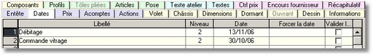
The Level field is calculated for the whole order.
The Date field contains the calculated date.
The “Force date” field and the “Validate the date” checkbox are restricted to users with “Dates validation” access right.

Version 7.2.31 | 13/10/2006
Modified tables |  | Created tables | Modified index
??? |  | ??? | ???
Global variables for coupled designs : New variables available for use into coupled designs.
_ShapeAssembly returns the shape of the overall assembled design as variables _Rectangle, _FullBow, …and returns the value -1 in case the design is not a coupled design.
Variables _DimAAssembly to _DimLAssembly return the production dimensions at the assembly level, and return 0 in case of no assembly.

Version 7.2.30 | 07/09/2006
Modified tables |  | Created tables | Modified index
??? |  | ??? | ???
Initialization of some WinPro variables modified : Variables _SashLeaf1Axis [ ] to _SashLeaf6Axis [ ] return since this release the axis of leves calculated with a base of production dimension, when the user used the asymmetric leaves feature or not.
Note : Until now those variable stored the value input as for an asymmetric leaf only. Before we proceed this behaviour change, most customer have been consulted through a mailing.

New global variable: _DecentertSash [ ] : This returns True() or 1 when leaves of the indexed sash frame is asymmetric, and returns False() or 0 otherwise.

New variables: ClearanceAxeVent1 to ClearanceAxeVent6 : those sash frame variables allow the user to define the sash frame axis by formulae, with assigning this value. If the user set asymmetric leaf value from the appropriate customer order dialog, tose input values will be the only ones considered by Winpro.

Module Glazing receiving: This new module enables a new menu entry point into the Production Management process named « Reception glazing». This interface shows the user which glass units are already received using various filters. One of the filters is a “Received” checkbox, and when unchecked, only the not received yet glass units are listed; when checked with non greyed background, only received glass units are shown, and when checked with greyed background, all glass units are listed.
A new tab in the customer order, “Reception Glazing”, is enabled, and lists the ordered glass units. Received units are outlined in green colour, others are in red colour.

Module Customer Relationship Management: This module adds new functionalities to the customer set up, the salesman set up, and add a new menu entry point : Datas – Lists – Print visits / Salesman.
This module allows to manage with a list of rendez-vous for each salesman. For each rendez-vous, a date forced by a user having the “Direction” access right mybe set, as well as a comment text. The salesman has also access to an input field for the date of the rendez-vous, as well as a manual comment text.
For each visit a combo list is available to set the type of visit and this list is user definable through winpro.ini, as shown in the below example:
[TypeVisites]
Count = 3
; The Count value correspond to the number of visit type to list
1 = First contact
2 = Measurement
3 = Down Payment
4 = Complaint after installation
When the « Locked » box is set in the customer record, a warning mail is automatically sent to the salesman linked to the customer. This feature is to be used with a specific dll wpcomm.dll, into the WinPro base directory.
This feature renames the “T.O.” tab of the customer record as “Datas and stats”, as you may define objectives for each customers.
On the printed visit list is shown a comparison between results and customer objectives.

Version 7.2.29 | 27/08/06
Modified tables |  | Created tables | Modified index
??? |  | ??? | ???
New graphic instruction : The Slope (x1,y1,x2,y2) function returns the angle between an horizontal line and a line defined with 2 points.
a := Slope (x1,y1,X2,Y2)
b := 90 – Slope (x1,y1,x2,y2)
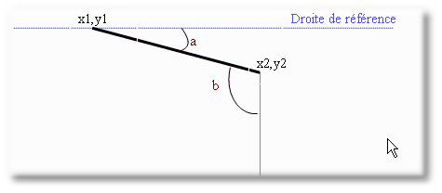

New drawing instructions with continuity feature:
New instructions are available in order to define free shapes to be fulfilled with a brush. Those free shapes are made with a set of drawing instructions linked one another by their extreme points.
Arc (cx, cy, radius, a1,a2,b1,b2) : Trace a circle with a start point corresponding to the end point of the previous instruction.
Arc2 (x0, y0, x1, y1,a1,a2,b1 ,b2) : Trace a circle arch with a start point corresponding to the end point of the previous instruction.
ArcSensRotation(0 ou 1) : Define a rotation orientation for arches following this instruction.
Bezier (x1, y1, x2, y2,x3, y3) : Trace a Bézier curve which start point corresponf to the end point of previous intruction.
Line (x1, y1) : Trace a line which start point is the end point of previous instruction.

StartPath () : Set the start of a new shape composed of several functions allowing a continuity.
EndPath () : Close the shape.
BorderPath () : Close the shape and draw it with 1 pass.
FillPath () : Fill with a brush the created shape.
FillAndBorderPath () : Combines properties of both previous instructions.
Sample codes are provided with winpro.chm help file compiled at 01/09/2006

New drawing instruction:
Arc2 (x0, y0, x1,y1,height,thickness,half) : Draw a circle of given thickness.
Sample codes are provided with winpro.chm help file compiled at 01/09/2006

Bows sequencing:
Those functions can be used to calculate a cutting sequence of circle arches into trapezium sub-shapes.
Many cutting sequence options are available:
First stage: Initializing
Before starting a cutting sequence of a bow, the engine needs to be correctly initialized for a good behaviour.

BowCutInit (): This necessary function reset the status. Always returns 1.
Syntaxe: a := DecArcInit ()

BowCutSetOverLenghts : This facultative instruction set up the additionnal dimensions shown on the drawing, for the trapezium shapes that will be calculated. Over dimension a and c might be a loss due to the assembly type. Always returns 1.
Syntax: a := BowCutSetOverLenghts (a, b, c, d)
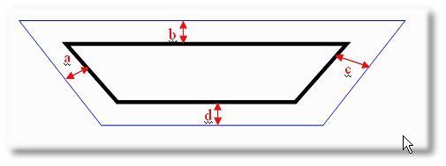
Note :
The rotation is considered clockwise, then:
• a correspond toi the start
• b correspond to the outer side
• c correspond to the end
• d correspond to the inner side

BowCutSetUsualWidths : This facultative instruction defines the sections that WinPro will have to use for trapezium calculation.
Up to 10 sections may be predefined, by increasing order. If less than 10 sections are usefull, you must set zero to other values.
If all values are set to zero, Winpro will calculate the section of each trapezium automatically. Always returns 1.
Syntax: a := BowCutSetUsualWidths (Section1, Section2, Section3, Section4, Section5, Section6, Section7, Section8, Section9, Section10)
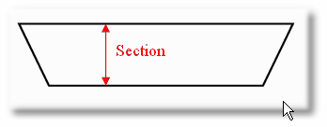
Note: You should know that whatever the calculation method used is, the generated trapezium shape will always have an uniform section.

BowCutSetMinLength : This is facultative and allow the user to set the minimum length for the trapeziums calculated. The value of this minimum length must include the eventual corrections defined with function BowCutSetOverLenghts. Always returns 1.
Syntax: a := BowCutSetMinLenght (value)
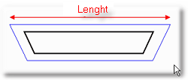

BowCutPenalty : This facultative function will affect WinPro for the quantity of trapezium it has to generate. In a first time a value of 5000 is advised, but will need to be adapted to your needs.
The greater the value is, the more reduced will be the obtained number of cuts for the bow.
Always returns 1.
Syntax: a := BowCutPenalty (5000)

Second stage: Bows set up
It is necessary to define the arch(es) composing the bow.
By definition, one radius is for one curve.
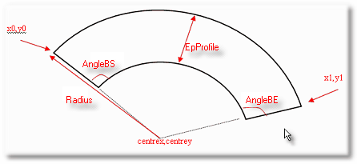

BowCutDefineTmpBow : This necessary instruction is setting up the arch nature for WinPro.
Always returns 1.
Syntax: a := BowCutDefineTmpBow (x0, y0, x1, y1, centrex, centrey, radius, EpProfile, 0)

Notes:
• The positions of d'angleBS and d'angleBE depend on the last setting which is worth 0 or 1.
• The last setting must always be set to 0 to validate a clockwise rotation. The anticlockwise setting 1 cannot be used at the moment.

BowCutDefineTmpStart : This facultative function set the angle corresponding to the start of the curve. Always returns 1.
Syntax: a := BowCutDefineTmpStart (angleBS, 180 - angleBE, 0, 0, 0)
Note : The 3 last settings must remain with zero values.

BowCutDefineTmpEnd : This facultative function set the angle corresponding to the end of the curve. Always returns 1.
Syntax: a := BowCutDefineTmpEnd (angleBS, 180 - angleBE, 0, 0, 0)
Note : The 3 last settings must remain with zero values.

BowCutAddBow : This necessary instruction stores the bow properties just defined into an array. This returns -1 in case of error, and the number of arches calculated and already stored in the array otherwise.
Syntax: a := BowCutAddBow ()

BowCutGetNbBows : This function returns the number of arches calculated stored in an array, and maybe then used at any time during the sequencing calculation.
Syntax: a := BowCutGetNbBows ()

Third stage : Quantify the sequencing
The sequencing will be processed in 2 passes, he 1st one is facultative.
The result will depend on initialization criteras et of circle arches properties defined.

BowCutGuessNbTrapeziums: This is facultative, and returns:
The ideal quantity of trapezium shapes needed to produce the bow.
-10 in case of initialization problem.
-5 in case of a problem during precalculation (due to wrong or missing values).
-1 in case WinPro cannot calculate a solution due to assigned constraints (no SectionStd important enough, impossible to find a long enough segment combination for the specified limit, ...)
Syntax: a := BowCutGuessNbTrapeziums ()

BowCutSetNbTrapeziums : This function stores the number of trapeziums requested for the sequencing.
Returns 1 when the requested quantity is accepted, -1 otherwise
Syntax: a := BowCutSetNbTrapeziums (value)

Fourth stage: Generate & consult the sequencing
The sequencing is processed as soon as the instruction BowCutInfosTrapezium is detected in the code.

Generate & check the sequencing
The sequencing is generated after execution of below function initialized with -1 values.
Returns:
-10 in case of initialization problem
-1 in case of undefined error
1 in case of no error.
Syntax: a := BowCutInfosTrapezium (-1, -1, -1)
Note : This stage is facultative and will mainly be used for debugging purposes.

Display the result of sequencing
You can then use the same function to consult the sequencing.
Here it returns -1 or -10 in case of error, otherwise it returns te requested value corresponding to the 3rd setting of the function.
Syntax: a := BowCutInfosTrapezium (0, n° of the trapezium, InfoType)
InfoType is worth one of the following values:
1 = length of the bottom side
2 = length of the top side
3 = Left angle
4 = Right angle
5 = Top left angle
6 = Top right angle
7 = Shift value of the left peak (from the top) – Always returns zero, function is not yet implemented.
8 = Shift value of the right peak (from the top) – Always returns zero, function is not yet implemented.
9 = Total lenght
10 = Section
11 = Is worth 1 With left peak, returns zero otherwise - Always returns zero, function is not yet implemented.
12 = Is worth 1 With right peak, returns zero otherwise - Always returns zero, function is not yet implemented.
13 = x position of the top left point
14 = y position of the top left point
15 = x position of the top right point
16 = y position of the top right point
17 = x position of the right peak - Always returns zero, function is not yet implemented.
18 = y position of the right peak - Always returns zero, function is not yet implemented.
19 = x position of the bottom right point
20 = y position of the bottom right point
21 = x position of the bottom left point
22 = y position of the bottom right point
23 = x position of the left peak - Always returns zero, function is not yet implemented.
24 = y position of the left peak - Always returns zero, function is not yet implemented.

An illustrated example of the use of this new feature will soon be placed here.

Version 7.2.28 | 31/08/06
Modified tables |  | Created tables | Modified index
??? |  | ??? | ???
Transom input: At transom input stage, WinPro is able to keep in memory the properties of the last transoms input. To store information of the first input trasom instead, simply set this key into System section of Winpro.ini.
[System]
Traverse Static = 0(keeps in memory the properties of the first transom input)
= 1(keeps in memory the properties of the last transom input)

Version 7.2.27 | 28/07/06
Modified tables |  | Created tables | Modified index
??? |  | ??? | ???
Optimized windows list: The WinPro batch name is now printed onto this document.

Version 7.2.26 | 24/07/06
Modified tables |  | Created tables | Modified index
Atelier.dbf |  | ??? | ???
Factory screens / Production spots: A new global variable _CatProductionSpot is initialized by the content of the production spot running WinPro. Then the developer can now implement specific code for a given production spot.
Example : Display a drawing that concerns a unique production spot, and not others

Version 7.2.25 | 17/07/06
Modified tables |  | Created tables | Modified index
??? |  | ??? | ???
Clearance sash mullion: 6 new global variables added for sash frames:
_ClearanceSashMullion1 [SashIndex] correspond to local variable: Clearance1
_ClearanceSashMullion2 [SashIndex] correspond to local variable: Clearance2
…
_ClearanceSashMullion6 [SashIndex] correspond to local variable: Clearance6

Module Glazing export: This exports of glazings dxf files during glazing order printing. You need to create a new key into Glass section of Winpro.ini :
[Glass]
VitrageDXFpath = Path to dxf target directory

Processing time: Winpro speed has been enhanced in certain cases:
- When skipping from one window to another into a customer order.
- In case of system changes into a customer order.

Version 7.2.24 | 06/07/06
Modified tables |  | Created tables | Modified index
??? |  | ??? | ???
Limit RAL : This only concerns users who enabled the « Limit choice of Ral Colours ». By default, having input a RAL colour design, WinPro will evaluate each bar length in order to find an article with a corresponding colour. In case WinPro do not find a colour corresponding to the colour input, it will consume the appropriate article from the Description tab of the profile set up.
With adding a new key into the WinPro.ini file, initialized at 1, Winpro will straight consume the appropriate article from the description tab of the profile, in case of RAL colour design input.
[System]
Limiter RAL = 0(default) or 1
; 1 : Winpro cannot consume the appropriate article from the bar length tab of the profile set up in case of RAl colour input, AND the system is checked as “Limit Choices for RAL colours”.

Roller shutter valorisation: A new field “Fixed price” is added to the roller shutter tab of the customer order, only if the price of the window is also set as “Fixed price”.

Version 7.2.20 | 23/06/06
Modified tables |  | Created tables | Modified index
??? |  | ??? | ???
Export glazing DXF (module DXFV): At the glazing order printing stage, Winpro export the drawing of each glass unit as a dxf file. Two new keys added to winpro.ini file
[Glass]
; VitrageDxf = 1 => enable dxf export
; VitrageDxf = 0 => disable dxf export
VitrageDxf = 1
; VitrageDxfPath = Path where dxf is generated
VitrageDxfPath = C:\WinPro\Dxf
Also two new keys added for the module.ini file:
[DXF]
Version AutoCAD = R2000 (default value), or R14
Epaisseur Ligne = 35 (default value) => value accuracy 1/100e of mm

Version 7.2.18 | 19/06/06
Modified tables |  | Created tables | Modified index
??? |  | ??? | ???
Price lists calculation : It is now possible to input the composed panels as a standard filling during a price list creation.

Version 7.2.17 | 17/06/06
Modified tables |  | Created tables | Modified index
??? |  | ??? | ???
New variables : New global variables added:

_NBowsFrame corresponding to the local outer frame variable Nbows
_ CenterXOuterFrame [ ] corresponding to the local outer frame variable FrameXCenter [ ]
_ CenterYOuterFrame [ ] corresponding to the local outer frame variable FrameYCenter [ ]
_ RadiusOuterframe [ ] corresponding to the local outer frame variable FrameRadius [ ]
_ OpeningOuterFrame [ ] corresponding to the local outer frame variable FrameOpening [ ]
_ StartAngleOuterFrame [ ] corresponding to the local outer frame variable FrameStartAngle [ ]
_ EndAngleOuterFrame [ ] corresponding to the local outer frame variable FrameEndAngle [ ]

_NBowsFrame corresponding to the local outer frame variable Nbows

_CenterXOuterFrame [ ] corresponding to the local outer frame variable FrameXCenter [ ]
_CenterYOuterFrame [ ] corresponding to the local outer frame variable FrameYCenter [ ]
_RadiusOuterFrame [ ] corresponding to the local outer frame variable FrameRadius [ ]
_OpeningOuterFrame [ ] corresponding to the local outer frame variable FrameOpening [ ]
_StartAngleOuterFrame [ ] corresponding to the local outer frame variable FrameStartAngle [ ]
_EndAngleOuterFrame [ ] corresponding to the local outer frame variable FrameEndAngle [ ]

Packaging management: For users of the module of packaging. It is now possible to select multiple lines of orders when packaging and it is also possible to specify if a window is to be packaged. To enable those features, simply add keys into [Packages] section of Winpro.ini file, as follows:
[Packages]
Multiselection = 1
; 1 enables multiple orders selection mode – 0 disable it
PackageWindow = 2
; Value 0 checks the box and set it as invisible for the user
; Value 1 unchecks the box and set it as invisible for the user
; Value 2 defaultly checks the box and leaves it available for the user
; Value 2 defaultly unchecks the box and leaves it available for the user
Version 7.2.16 | 16/06/06
Modified tables |  | Created tables | Modified index
??? |  | ??? | ???
Export Saws: When processing a technical export, WinPro processes now any existing saw within a set up, even when the saw is mentioned through variable SawId as part of an exported formula.

Version 7.2.15 | 14/06/06
Modified tables |  | Created tables | Modified index
Systeme.dbf |  | ??? | ???
Outer frame segmentation for Nederlands: A new checkbox is added into the description tab of the System set up dialog, named “Frame without reveal”. Enabling this option will display a new similar checkbox in the Descritpion tab of Sash frame set up dialog when belonging to the system, also named Frame without reveal..
Until now, WinPro allowed us to mix into a same design inward and outward opening pane types. The pane type set up is done using the checkbox Reverse frame.
Enabling this new box into the sahsh frame add a new pane type called “No reveal”.
The outer frame variable SegmentType [ ] returns now one of the following values: Normal, Reversed, FrameNoReveal.
The transom variable SegmentType [ ] returns now one of the following values: NormalT, ReversedT, NormalZ, ReversedZ, TNoReveal, IntLeftL, IntRightL, ExtLeftL, ExtRightL.
Moreover, enabling the system checkbox allows the user to define empty parts, giving details on eventual additional reveal edge of the vertical transom if required,
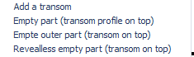
Example : When a segment of a vertical tansom is touching, at the same time, a sash frame with Reverse frame feature set, and touching an empty part set as Revealless empty part, the SegmentType[SegmentIndex] variable will return ExtLeftL or ExtRightL
Tip : The L character may be interpreted as if it was the profile reveal edge, the outer reveal edge value on the right for ExtRightL.
Refer to release note 4.1.0 for details concerning segmentation with reversed frames.

Version 7.2.13 | 08/06/06
Modified tables |  | Created tables | Modified index
??? |  | ??? | ???
Translations: At each running of Winpro, a check of the translation files is done in order to delete doubles.

Version 7.2.12 | 15/05/06
Modified tables |  | Created tables | Modified index
??? |  | ??? | ???
Article file – Suppliers tab: A texte zone is added to the Supplier tab of the Article set up dialog. This field is for personal notes and will not be processed by WinPro.
Version 7.2.11 | 29/04/06
Modified tables |  | Created tables | Modified index
??? |  | ??? | ???
New variable : _GlazingOrder. This variable let us know whether WinPro calculate the set up formulae in order to print a glazing order, or not. This variable will then condition some drawing displays for glazing bars to be only printed onto the glazing order.
Components weight: A new “Weight” column is added to the interface at the Component tab of the customer order. This weight value is automatically calculated by WinPro whatever is the calculation mode for the design’s weight, automatic or manual with the use of the _LoadingWeight variable. (refer to release note 7.2.2)
The component weight is calculated by WinPro as follows:
When an article is consumed with quantity x, WinPro increases the variable of x times the value of the weight field of this article.
When a profile is consumed with quantity x and length y, WinPro increases the variable of x*y times the value of the weight field of this article.

Customer message with pop-up : Into winpro.ini file, you can set up your own messages. Into the « Finance » tab of the customer record, the appropriate field needs to be set with the message references. Finally, each time the customer record is opened, for each printing for this customer, for each order input for him, or when consulting current orders, a pop up message window for the WinPro user will be displayed.
Example of Winpro.ini file configuration:
[MsgClient]
Count = 2
; This value is the number of messages, listed below
1 = Always late for payments
; Message n°1 is …
2 = No more money...
; Message n°2 is …

Version 7.2.10 | 28/04/06
Modified tables |  | Created tables | Modified index
??? |  | ??? | ???
Roller shutter supplier order : From the Action tab of the cutomer order, you can now use a new checkbox, “Supplier order form”, which will allow the printing of a supplier order for a roller shutter supplier. Then for each roller box, you have to set with a checkbox if the shutter needs to be ordered to the supplier, and set also a supplier code.
This feature is available for any Roller Shutter module’s user.

Automatic execution for external program: This offers the ability to run external programs during specific WinPro processes for the customer order:

- Print confirmations
- Validate confirmations
- Financial approval
- Aprove confirmations
- Batch generation
- Optimization
- Launch production
- Print delivery preparation
- Print delivery note
- Print invoice

Those processes are set up into a new section of Winpro.ini file:

[Extern program execution]
Execution=1 ;1 enables the feature, 1 disables it
Confirmation printed = prog.exe;param1 param2;
Confirmation validated = prog.exe
Financial validation = prog.exe;param1;#order#
Confirmation on hold =
Ready for optimization =
In production =
Delivery preparation =
Delivery note printed =
Invoiced =

If Execution key value is not 1 => no execution
#order# may be replaced with either customer order number or batch number

Version 7.2.6 | 10/04/06
Modified tables |  | Created tables | Modified index
Systeme.dbf  Caisson.dbf |  | ??? | ???
New module CFL: This is intented to be used with WinproLight : Light Supplier Order.
This module gives access to the assignment, for each system or roller shutter box, of a supplier code in order to print supplier order forms from the Action tab of the customer order.
This way, for a given order, designs, shutters, articles, additional supplies as articles or profiles and even bent shetts supplied will be splitted by supplier(s) at the print step.
Confirmation date:
A new combination is added for the delivery date onto the printed confirmation, the ability to use macro #6#.
As reminder, access keys to texts are (via strings.exe):

For installation: | DOC_POSECOMMANDE
For delivery: | DOC_LIVRAISONCOMMANDE
For pick up delivery mode: | DOC_ENLEVEMENTCOMMANDE
For undefined delivery mode: | DOC_FOURNITURECOMMANDE

Available macros until now were:
#1# | Delivery date printed as a week number
#2# | The day number (1 to 31) flags the number of weeks for delivery to be done.
#3# | Exact delivery date is printed
#4# | This text is printed before the delivery date; for macro #1#, it is replaced with text « during week » (identifier « DOC_LA_SEMAINE »); for macro #2#, replaced with text « in » (identifier « DOC_DANS_(x weeks) »); for macro #3# with the text « the » (identifier « DOC_LE (date) »).
#5# | This text follows the delivery date printed; for macro #2#, the macro is replaced with « week(s) » (identificateur « DOC_SEMAINE(S) ») ; for macros #1# and #3#, macro #5# is deleted.
The new macro :
#6# | The customer delay is printed using a week number format

Version 7.2.5 | 08/04/06
Modified tables |  | Created tables | Modified index
Compos.dbf |  | ??? | ???
Module Restricted Version (VF): This module locks any access to the technical set up, whatever the user access rights are, except for glass units set up, labours set up and optimization settings that remain available for the user.
The user can also create ihis own articles but those would be only for use as additional article supplies into customer orders and quotations.

Version 7.2.2 | 28/03/06
Modified tables |  | Created tables | Modified index
??? |  | ??? | ???
Macro #2# : The macro is now affordable into decorative, plain and composed panels descriptions.
Brent: Due to the huge increase of the energy price, most suppliers have implemented an additional price for glazing material. A new feature has then been implemented into WinPro in order to handle those variations of the IPE Brent index according the weight of glazing. This additional price is cumulated to the current cost price in order to calculate a correct pricing for the glazing orders. This coefficient to apply to the glazing weight is defined into winpro.ini as follows
[Glass]
Coeff plus value vitrage = x
x correspond to the coefficient applied to the glazing weight and determine the additional price added to Current Cost Price, e.g. : 0.104 (this value may be negative)
Design weight:
Version 7.1.30 introduced the global variable _LoadingWeight, to be increased by formula.

With this version, if the variable is not increased within formula, Winpro will automatically calculate the weight using the weight field of the article set up dialog, with cumulating all design components.

Version 7.2.1 | 15/03/06
Modified tables |  | Created tables | Modified index
??? |  | ??? | ???
Leaves drawing order: This sequence is defined into the « Description » tab of sash frame set up dialog, and may now be modified by formula, using the new variable SortingSash. This variable might be particularly usefull for sliders set up.
This variable is defined for local use only, and should be set up from the first profile formula of fittings frames.
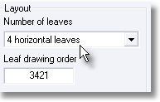

Version 7.2.0 | 14/03/06
Modified tables |  | Created tables | Modified index
??? |  | ??? | ???
Factory screens / production Spots: When a given production spot monitor is used by several users, working on the same or different tasks, it is now possible to identify the user before scanning the frames. It is then not necessary anymore to restart Winpro. To enable the feature, the key User = 1 must be set into [workplace] section of winpro.ini file. This new key has a default value of 0.

